Dance Notation Processes of Reconstruction Series 1: Transcultural Transmission of Helen Tamiris’ Negro Spirituals (1914)
  - Notes for Students

Introduction to Negro Spirituals
The Negro Spirituals were written during the eighteenth and nineteenth centuries and reflect important aspects of the lives of millions of black people in America who were forced into slavery, labouring for the financial gain of others.

By the end of the seventeen hundreds, slaves had been an integral part of the American economy for more than a century. Prohibitions against speaking the language or practicing the religion of their forebears had been brutally enforced and by this time, though remnants of their African heritage remained, slaves in America had begun to develop their own culture based upon what was allowed them by their masters.

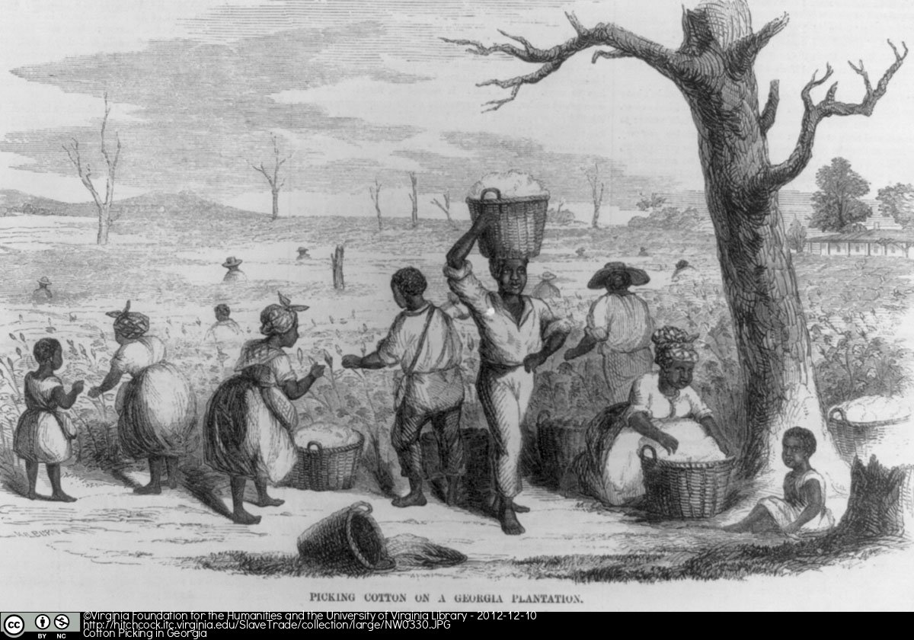

Cotton Picking in Georgia, 1858; Image Reference NW0330, as shown on www.slaveryimages.org, compiled by Jerome Handler and Michael Tuite, and sponsored by the Virginia Foundation for the Humanities and the University of Virginia Library.

The church was the only place that slaves could congregate without white overseers taking note of all that they said and did. As long as they reflected Christian values, the prayers and songs that they sent to their Maker were uncensored. The Spirituals written by and for Negro slaves serve more than one purpose.

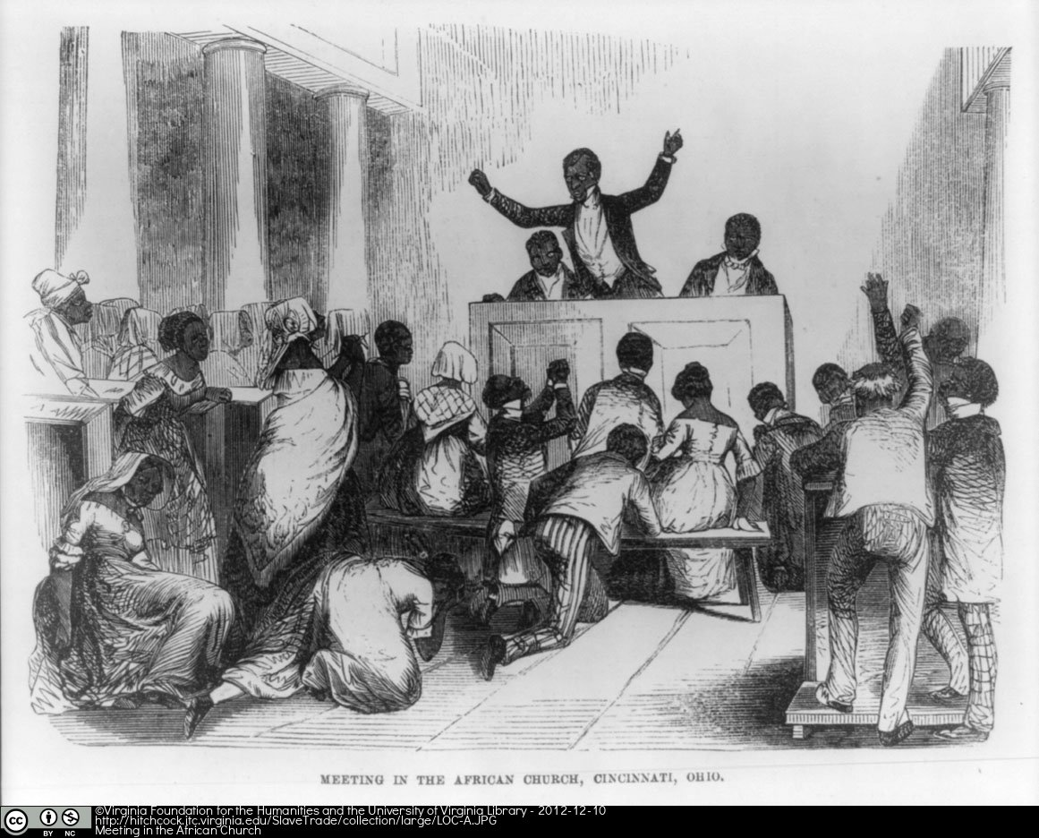

Preacher exhorting his congregation during a meeting in the African Church, Cincinnati, Ohio, 1853; Image Reference, LOC-A, as shown on www.slaveryimages.org, compiled by Jerome Handler and Michael Tuite, and sponsored by the Virginia Foundation for the Humanities and the University of Virginia Library.

The Spirituals are expressions of faith in the existence of a Heavenly Father who, in contrast to all earthly authority, was kind and just and who had prepared for them a place in paradise that featured peace and plenty. The Spirituals are also commentaries on the unimaginable suffering that was an inseparable part of life for slaves and many contain pleas for God to release His black faithful from the torment of being white folks’ chattel. While other Christians sang thanks to God for the bounty he bestowed upon them, slaves sang longingly of death; of being allowed to leave behind lives from which was wrung the monetary profit to build a nation. ‘I look over Jordan and what do I see? Comin’ for to carry me home. A band of angels comin’ after me! Comin’ for to carry me home!’

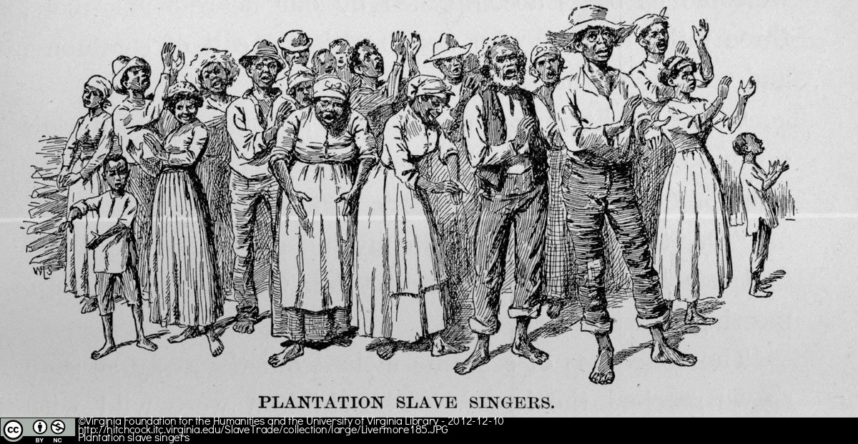

Illustration from Mary Ashton Rice Livermore chapter on Plantation Scenes and Negro Song; Image Reference Livermore185, as shown on www.slaveryimages.org, compiled by Jerome Handler and Michael Tuite, and sponsored by the Virginia Foundation for the Humanities and the University of Virginia Library.

These songs are still sung in black churches throughout America and no one who gives them voice doubts for a moment that some contain codes telling of planned slave escapes. Because of the obvious need for secrecy, there are few primary sources to support this notion. But the existence of the Underground Railroad, a network of passages and safe houses through which run-away slaves travelled north to the Free States and Canada, is a historical reality. It was used by thousands of freedom seekers between the late eighteenth and the mid-nineteenth centuries. Harriet Tubman was the most renowned ‘conductor’ on the Underground Railroad and personally led hundreds of escapees along sections of the route. She was also fervently involved in other abolitionist and women’s rights struggles. Her activism earned her the nickname ‘Moses.’ All of this is referred to in the Negro Spirituals.

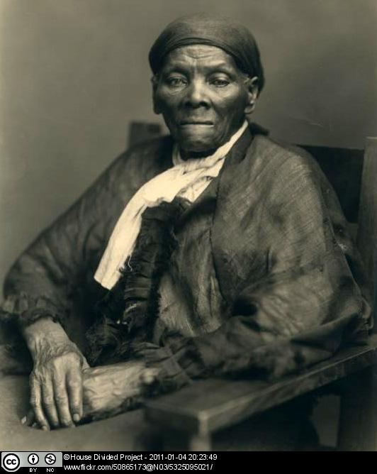

Portrait of Harriet ‘Moses’ Tubman, circa 1908. Photo by Emsberger, New York.

There is no question that the Negro Spirituals are expressions of the highest human aspirations by people forced to endure the lowest of human conditions. That such hope and spirituality could thrive in a people living under the burden of a system determined to reduce them to wealth-producing machinery tells us just about all we need to know about human capacity and resilience.

Helen Tamiris’ Negro Spirituals
Tamiris was interested in exploring African American culture and expressing “the spirit of the Negro people –in the first his sense of oppression –in the second, his fight– and struggle and remembrance” (Palfy, 1989: 40-41).

Negro Spirituals is a suite of eight short dances choreographed by Helen Tamiris, a pioneer of the American Modern Dance Movement. Created over an extended period of time—1928 to 1941—the dances reflect the characteristics of this genre with music from traditional Spirituals as well as the ideas of the choreographer. In 1965 the eight choreographies were put together into one whole performance by the Dance Department, School of Performing Arts at the Ohio State University. In 1967 Lucy Venable notated the choreographic score using Labanotation which has enabled subsequent reconstructions of this work.

The reconstruction of Helen Tamiris’ Negro Spirituals by Jean Johnson-Jones
The process of reconstruction involves careful research into the artist and her work. For this 2012 reconstruction of Negro Spirituals, Jean Johnson-Jones addressed issues such as directorial interpretation of Labanotation scores, especially historical accuracy and/or authenticity, transcultural transmission and the ‘handing-down’ process, the idea of ‘choreography of struggle’, and (re)appropriation.

Jean Johnson-Jones staged six of these dances from the Labanotation score: Go Down Moses, Swing Low, Git on Board, Joshua. The dances were performed by Sophia Davis. While Johnson-Jones followed the notation in the score, the dances were interpreted based on her vision of the work that is its connection to the Negro Spirituals, the Underground Railroad, and Harriet ‘Moses’ Tubman. Further, the work was mounted as a multi-media production that includes a documentary film on the reconstruction process and ‘handing down’ of the dances as well as a photomontage of Harriet Tubman and artefacts of the Underground Railroad for the performance itself.

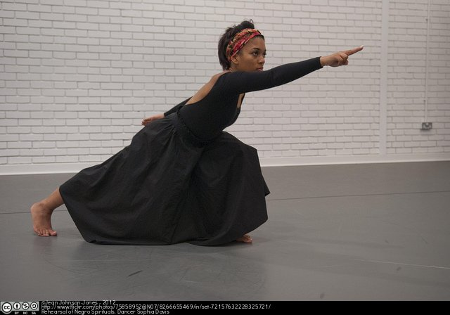

Sophia Davis rehearsing Tamiris’ Negro Spirituals, University of Surrey, 2012. Reconstruction and photo by Jean Johnson-Jones.

Palfy, B. (ed.) Studies in Dance History, Volume 1, Number 1, Fall/Winter 1989. Pennington, NJ: Society of Dance History Scholars at Princeton Periodicals.

