Ballet
  - Notes for Teachers

Background information
This e-learning package was created as part of a module aimed at year 2 undergraduates studying at (FHEQ) level 5 for a BA (Hons) Dance and Culture degree at the University of Surrey in Guildford, United Kingdom. Students have three contact hours per week (2 one and a half hour sessions in the studio). They are also expected to work independently and to do one online task between lessons as well as one hour practice. The module is assessed by completion of the online tasks and engagement with the technique class.

Learning package
This learning package contains a set of 10 online tasks, a complete resource list, and some suggestions for classroom activities. The online tasks contain approximately 10 hours of materials for independent and collaborative learning. They include:
- reflective questions with feedback,
- recommended readings and viewings,
- links to video clips,
- online discussion forums and mind maps.

Summary
This material focuses on the interplay between different aspects of ballet practice physical (mechanics of body and movement in space through somatic approaches), psychological, artistic, personal engagement and agency (action, reflection through specific tasks.) Students work on understanding the relationship between technique and expression, form and performance in ballet. They consider in particular in what way/s ballet is both a contemporary and a classical art form.

Aims
- To equip students with a critically reflective and embodied understanding of ballet technique.
- To develop the ability to interact online and share digital content.

Learning outcomes
- An embodied knowledge and understanding of key aspects of ballet technique supported with appropriate terminology and theoretical knowledge.
- A comprehensive understanding, through critical reflection, of the distinctiveness of the ballet genre.
- Ability to interact effectively within a group by contributing to online forums and mind maps.

Tools
In this learning package, two collaborative tools are used: Discussion forums and Mind maps.
Forums were created in the module website (VLE). From an activity, students can go straight in to forum via a direct link to the relevant discussion thread. Each thread should be clearly identified with the topic of the week (e.g. Inspiring quotes), a reference to the activity (e.g. Activity 4.5) and the instructions from the activity repeated (e.g. “Choose a quote from…”).
Sample forum discussion
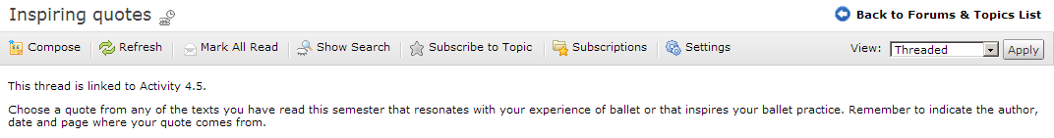
Mind maps for this module were designed using Mindmeister: http://www.mindmeister.com/
Activities included direct links to the relevant map. The map’s name corresponds with the topic (e.g. Attending to space in ballet). On the map students should also find a sample entry from the teacher.
Sample mind map
