Arts and Society
  - Notes for Teachers

Background information
This e-learning package was created as part of a module aimed at year 1 undergraduates studying at (FHEQ) level 4 for a BA (Hons) Dance and Culture degree at the University of Surrey in Guildford, United Kingdom. The module is worth 15 credits and lasts one semester (11 weeks). Students have one and a half contact hours per week. They are expected to do one online task before their weekly lesson.

Learning package
This learning package contains a set of 10 online tasks closely linked to in class activities, a complete reading and viewing list, and some suggestions for classroom activities. The 10 online tasks contain approximately 20 hours of materials for independent and collaborative learning. They include:
- reflective questions with feedback,
- list of resources with recommended readings and viewings,
- links to video clips,
- links to online discussion forums and walls.

Summary
This material focuses on concepts such as reality, semiotics, Marxist analysis, capitalism, and commodities in order to enrich the ways we engage with arts in our society. It takes students through a variety of art in different mediums —visual art, performances, films and dance pieces— where the artists involved engage with their historical moment and seek to inform, stir, shock, share or just establish conversations about the role that the arts play in society.

Aims
- To provide students with an overview of strategic developments in Dance and Film practice spanning the late nineteenth century to the present day that have particularly impacted upon, or responded to, issues of the arts and society.
- To stimulate an awareness of the interaction between Dance and Film practices and other allied cultural discourses, and of how artists are affected by, and in turn affect, the same.
- To understand and engage in digital practices.

Learning outcomes
Knowledge/Understanding:
- A basic knowledge of key developments in twentieth-century and contemporary Film and Dance practices.
- An understanding of how artistic practices are located within specific societal frameworks.
- An awareness of the pivotal role of institutional structures for artistic practice, as well as of strategies of artistic resistance to the same.
Cognitive/Intellectual Skills:
- Ability to engage with artistic practice and interplay across Film and Dance.
- Ability to debate the role of the artist in twentieth-century and contemporary society.
- Ability to locate and explain various definitions of the terms culture, and other cultural studies terms such as Marxism, feminism, subculture, and value.
Practical/Key Skills:
- Ability to identify iconic twentieth-century works of art (broadly defined).
- Ability to engage and make their own arguments and analysis of works discussed or assigned in lecture
- Ability to construct and clearly write an analytical essay about a piece of art (broadly defined).
Digital Skills:
- Demostrate ability to successfully upload visual items and notes on an online wall for sharing information with others.
- Contribute to an online critical discussion with other students in a forum.

Tools
In this learning package, two collaborative tools are used: Discussion forums and Walls.
Forums were created in the module website (VLE). From the activity, students can go straight in to the discussion area via a direct link to the relevant discussion thread. Each thread should be clearly identified with the topic of the week (e.g. What is art?), a reference to the task (e.g. Task 1) and the instructions from the activity repeated (e.g. “Ask three of your friends…”).
Sample forum discussion
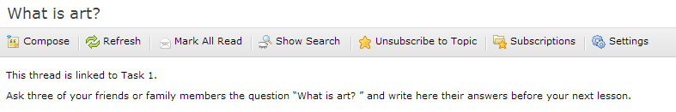
Walls for this module were designed using wallwisher: http://wallwisher.com/
Activities included direct links to the relevant wall. The wall’s name corresponds with the topic (e.g. Street art), and instructions of the activity are repeated for convenience (e.g. “Post a photo of…”). On the wall students should also find a sample answer from the teacher.
Sample wall
